Analysis of the effect of GDP on Life Expectancy

Abstract:

In this report I have analysed the link between GDP and life expectancy of six countries with data from the World Health Organisation and the World Bank and have found them to be independent variables this means that the rise in one does not necessarily mean a rise in the other however I do believe them to be linked with common factors affecting both individually.

Introduction:

This report is based on data gathered from the WHO (World Health Organisation) and the World Bank where I did a cross comparison between GDP and life expectancy of the six countries using methods such as the covariance matrix to understand the spread of data and Pearson correlation to see whether the two are correlated.

To begin with in this, I use terms such as GDP and life expectancy these should be defined:

. GDP (Gross Domestic Product) which is the measure of all economic activity with in a country and is calculated by adding up the total of government expenditure, consumer spending, foreign direct investment and the balance of trade.

. Life expectancy which is a prediction of how long a person from a given year is likely to live this is done in years and only for those born in that given year.

GDP and Life Expectancy over time:

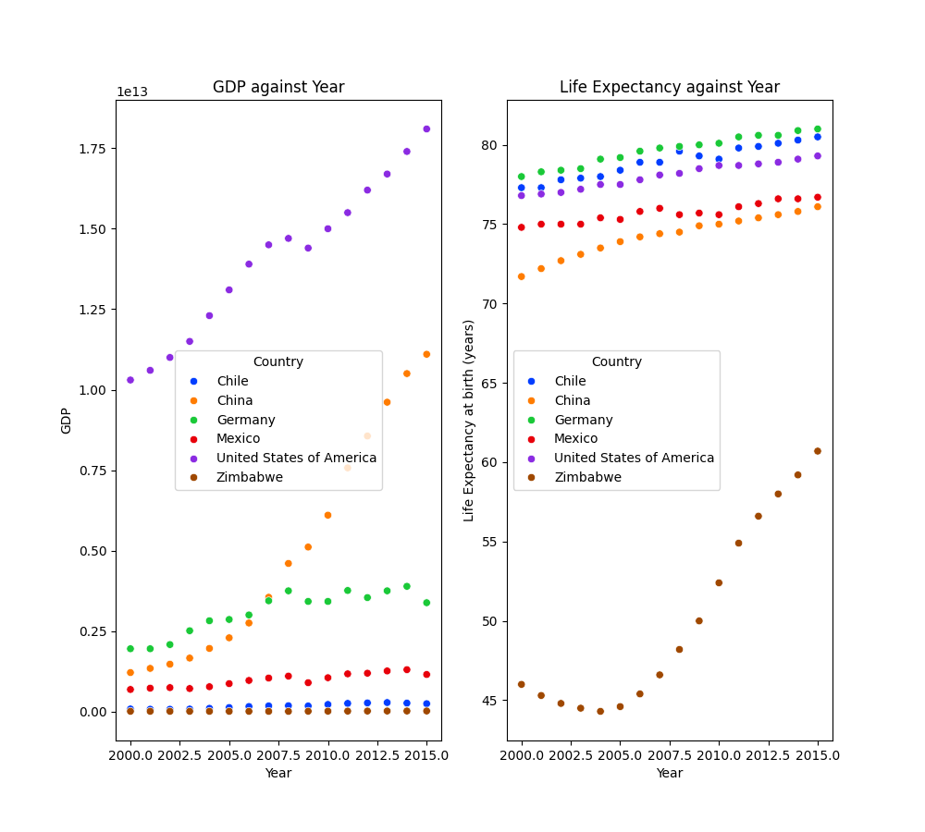

Figure1:

Figure one as shown above shows two scatterplots depicting the GDP and life expectancy of six countries over a period of fifteen years from 2000 – 2015.

These graphs display that over those fifteen years the countries with higher GDP’s tend to have a higher life expectancy with GDP out growing life expectancy which hovers around 0.2 – 0.3 for such countries like the United States when compared against one another, this is shown in figure two. However there is no clear link as the country with the highest GDP for example the US, does not have the highest life expectancy which would be Germany which only has the third largest GDP this can be further seen with China which despite having the second largest GDP has the fourth highest life expectancy this shows how potentially they are only linked through other factors such as government spending which will be discussed further on in the report.

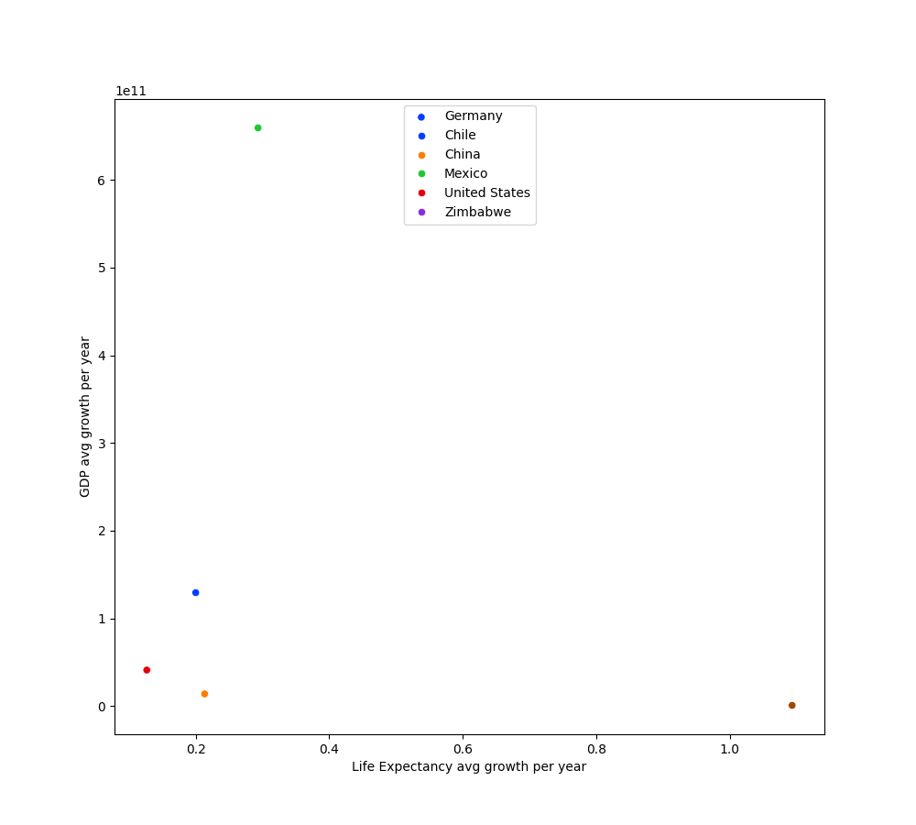

Figure 2:

Figure two as shown above displays the comparison of GDP to life expectancy of each individual nation with Germany and Chile being seen together as they score so close, with just over 10 Billion in growth for GDP leading to around 0.2 year rise in life expectancy, as well as the US and China being nearby, at around 5 Billion in GDP growth for 0.1 – 0.2 years rise in life expectancy respectively. However, there are two outliers in Zimbabwe and Mexico with Mexico having a high GDP growth to Life expectancy growth and Zimbabwe with the opposite this shows up on the covariance matrix with a far higher X variance and a slightly higher Y variance when compared to the covariance.

In relation to the covariance, it does indicate a strong correlation that a larger value of GDP will correspond with a higher life expectancy this would suggest a linear relationship between the two variables. However to the contrary of this a article from the world economic forum finds that in countries with higher GDP the relationship is opposite but only modest as when GDP is 5% percent above trend adults are 1% more likely to die.

Outliers:

Mexico:

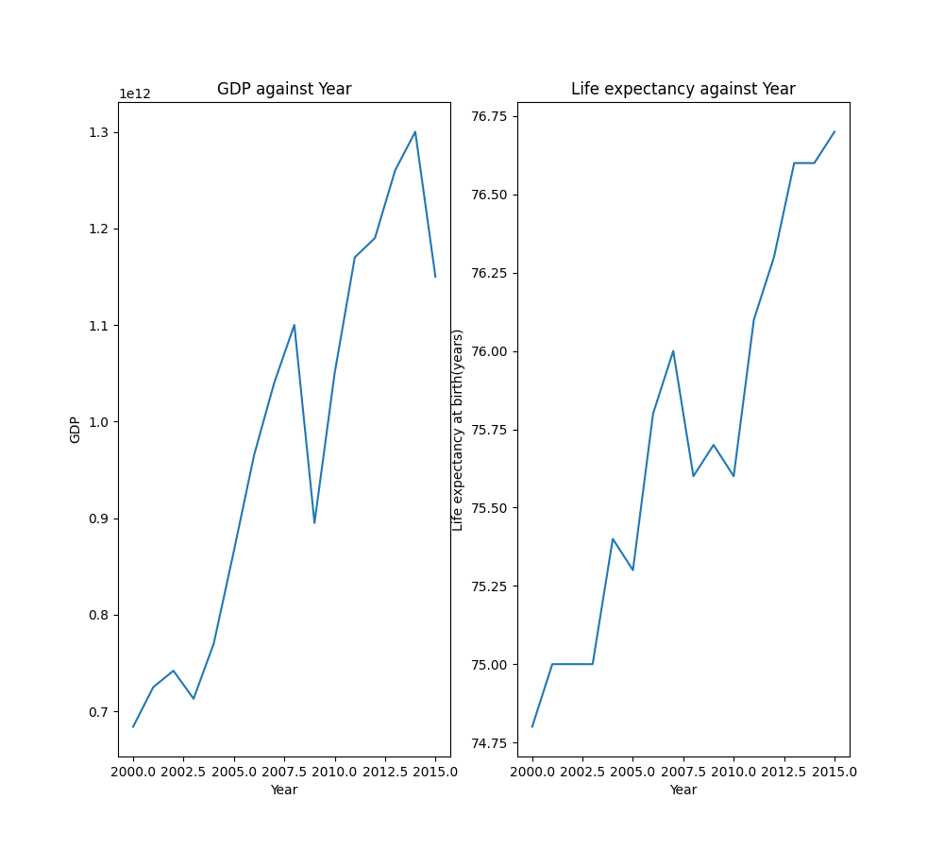

Figure 3:

Mexico shows a clear growth in both GDP and life expectancy however this does not mean they are correlated but merely linked through common factors such as crime rates and corruption because despite the growth in GDP with its GDP standing at over 1 trillion dollars in 2015 its life expectancy is almost 4 years lower than Chiles which has a GDP only in the hundreds of billions.

The possible reasons why mentioned above can be seen in that Mexico ranked 111th in 2015 on the corruption index by transparency.org this can mean that public services struggle to be ran due to lack of funding for things like healthcare which would help raise life expectancies. There are also high crime rates from 2000 – 2015 with on average 14.44 crimes reported per 100k population according macro trends & stats who site the world bank as their source. This suggests that the low rise in life expectancy of only around 2 years over the course of 15 years has to do with crime in the country more than GDP as that has risen by hundreds of billions in those same 15 years.

Zimbabwe:

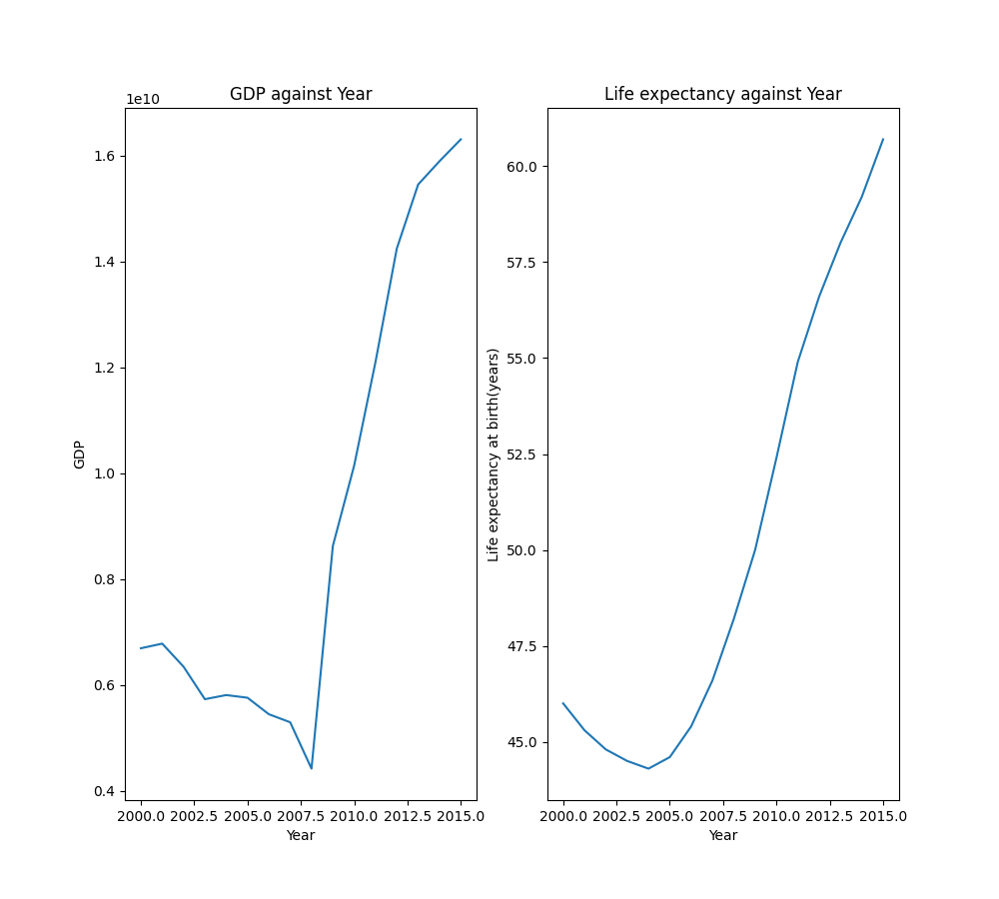

Figure 4:

Figure 4 displays Zimbabwe’s growth in GDP and life expectancy with their GDP having grown by around 12 Billion in that time compared to a rise of over 15 yeas in the same time frame for life expectancy.

This could be linked to the drop in food insecurity for children under 5 by 4.35% however malnutrition did increase by 1.03% coming from a study published by springer link, this drop in food security would though give reason to this rise in life expectancy as this measure is a prediction based on how previous years have fared and on current status of an area in relation to that. However, the GDP rise may be so small comparatively due to the mining boom in Zimbabwe due to it being mostly foreign companies owning and operating the mines and so therefore the profits mostly being removed from the country.

Conclusions:

In conclusion the Data does not display any clear correlation as proven by the P value generated when using the Pearson correlation calculation which gave a value of 0.0006 (rounded) this is far too close to 0 to say these too variables are correlated due the common threshold for a correlation being 0.3 and a strong correlation being 0.6 which it does not meet either how the covariance matrix does suggest a linear relationship which through other evidence presented could potentially be due to other linked factors for both variables.

Limitations:

This data did show some limitations however which should be considered with it being a small sample size of only 6 countries over a relatively short period of time this cannot truly prove any significant links between variables as there is a high margin for error with small sample sizes.

Sources:

<https://www.weforum.org/agenda/2016/10/the-relationship-between-gdp-and-life-expectancy-isnt-as-simple-as-you-might-think/>

<https://www.transparency.org/en/cpi/2015>

<https://www.macrotrends.net/global-metrics/countries/MEX/mexico/crime-rate-statistics>

<https://link.springer.com/article/10.1186/s12889-020-09295-z>